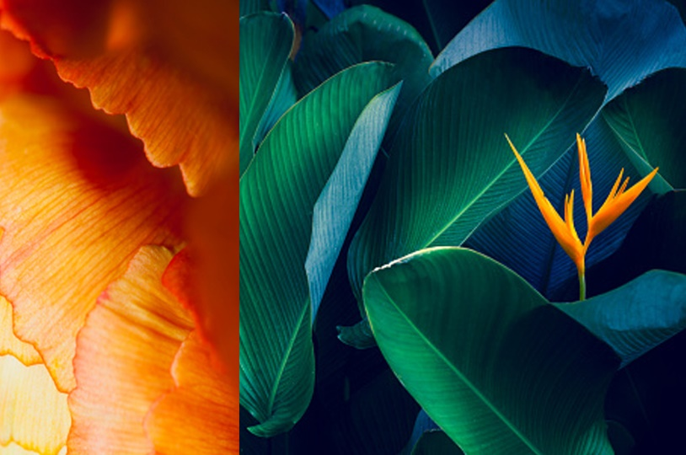

|  |
| --- |
| CS 1103 - FR02B  Lab 8 |
| By Ngoc Phuong Anh Nguyen - 3712361  March 2021 |

# **Application 1:**

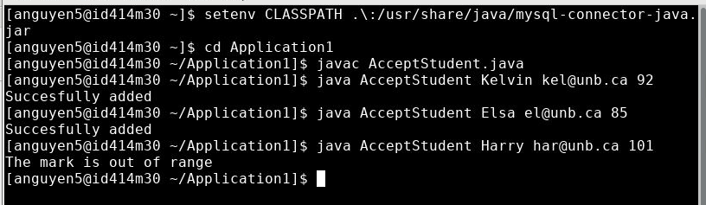

Figure : The AccepStudent running image (Screenshot)

# **Application 2:**

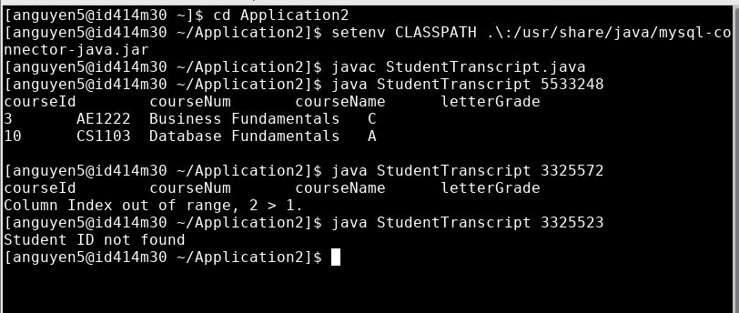

Figure : The StudentTranscript running image (Screenshot)